DRAWINGS:

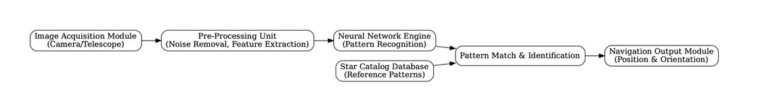

Fig-1: A schematic diagram showing the system architecture of the Neural Network for Star Pattern Recognition

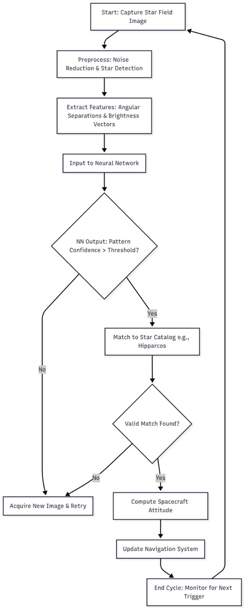


Fig-2: Flowchart

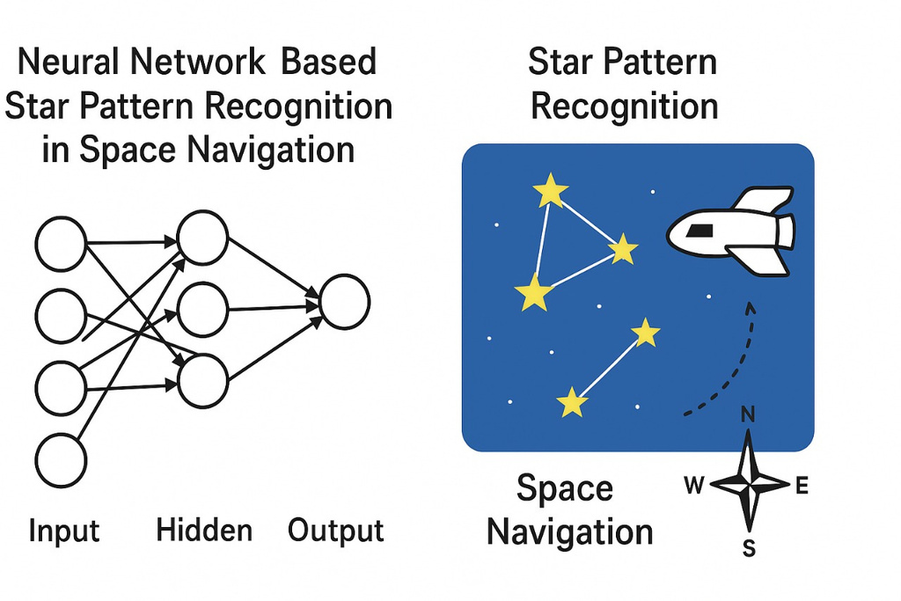

Fig 3 : A Use-Case Scenario showing recognition of star patterns using space navigation

